(Provide 2 options for all sections) The colors should be vibrant blues and yellow/gold (See ref in end)
The visual hierarchy should be: Hero (25%) → About (15%) → App (15%) → Homecoming (10%) → Council (15%) → Global Community (10%) → Get Involved (5%) → CTA (5%)
This keeps the website very close to the reference designs 2 JPEGS provided while also showcasing the Association's governance model, official vision, mission, and global alumni network from the approved Mahatma materials.

SECTION 1: HERO
Visual Direction - Option A - School entrance/gate at golden hour
Visual Direction - Option B - Wide campus aerial shot blended with subtle alumni silhouettes
MAHATMA ALUMNI ASSOCIATION
One School. Many Generations. Forever Connected.
Body Copy
From classrooms and corridors to cities and countries around the world, Mahatmites remain connected through shared memories, lifelong friendships, and a shared journey.
CTA Join Our Community | Explore The Alumni App
(Examples below)
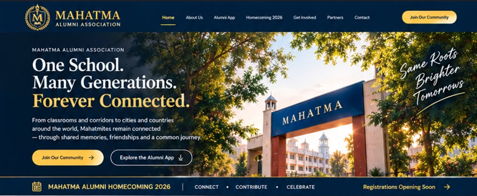
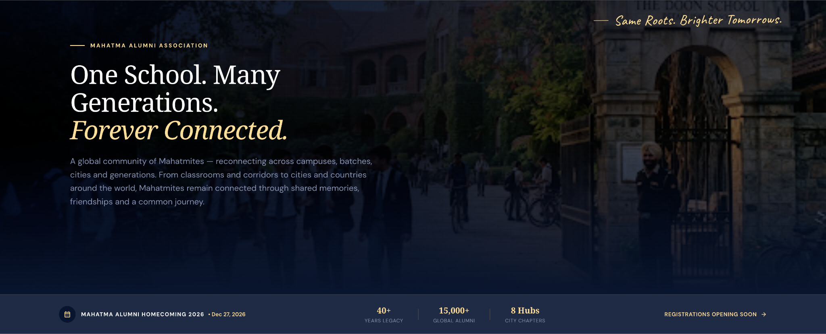

Need content for these if needed changes , need hero image in this size : image1
mahatma-assets
SECTION 2: ABOUT US + VISION & MISSION
(use real/stock images) Visual Direction - Option A Alumni walking together on campus
(use real/stock images) Visual Direction - Option B Mix of students, alumni and school architecture
ABOUT US
More Than an Alumni Network. A Lifelong Community.
Body Copy
The Mahatma Alumni Association brings together alumni across every campus and batch, creating opportunities to reconnect, contribute, and celebrate the journey that shaped us. Our community spans generations, professions, and geographies, united by the values that define Mahatma.
(All pillars in iconography)
Pillar 1
Connect Reconnect with classmates and build meaningful relationships across generations and geographies.
Pillar 2
Contribute Support the growth and development of students, alumni, and society.
Pillar 3
Celebrate Honor achievements, milestones, memories, and the enduring Mahatma spirit.
Our Vision
To build a vibrant global community of Mahatmites united by shared values, lifelong connections, and a commitment to advancing the legacy of Mahatma.
Our Mission
To connect, contribute, and celebrate while strengthening the Mahatma community across generations, professions, and geographies.
(Examples below)
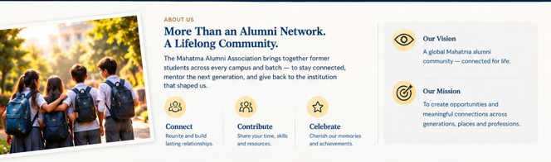
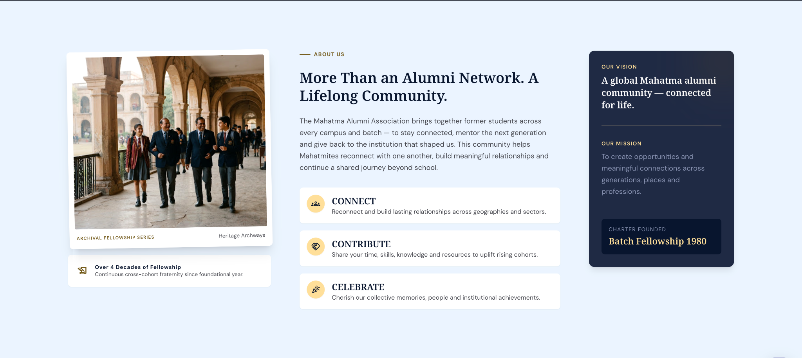

Need content for these if needed changes , need left image in this size : image2
mahatma-assets
SECTION 3: WHAT KEEPS OUR COMMUNITY CONNECTED
PILLARS OF ENGAGEMENT
What Keeps Our Community Connected
Meaningful relationships, shared experiences, and opportunities to connect, contribute, and celebrate together.
Card 1
Alumni Network
Reconnect with classmates, batchmates, and alumni across professions, cities, and countries.
Card 2
Mentorship & Guidance
Support students and young professionals through career guidance, mentoring, and knowledge sharing.
Card 3
Reunions & Events
Participate in alumni meets, chapter gatherings, reunions, and community celebrations.
Card 4
Community Initiatives
Contribute to social impact, educational programs, and community-driven initiatives.
Card 5
Chapters & Communities
Stay engaged through active alumni chapters across India and around the world
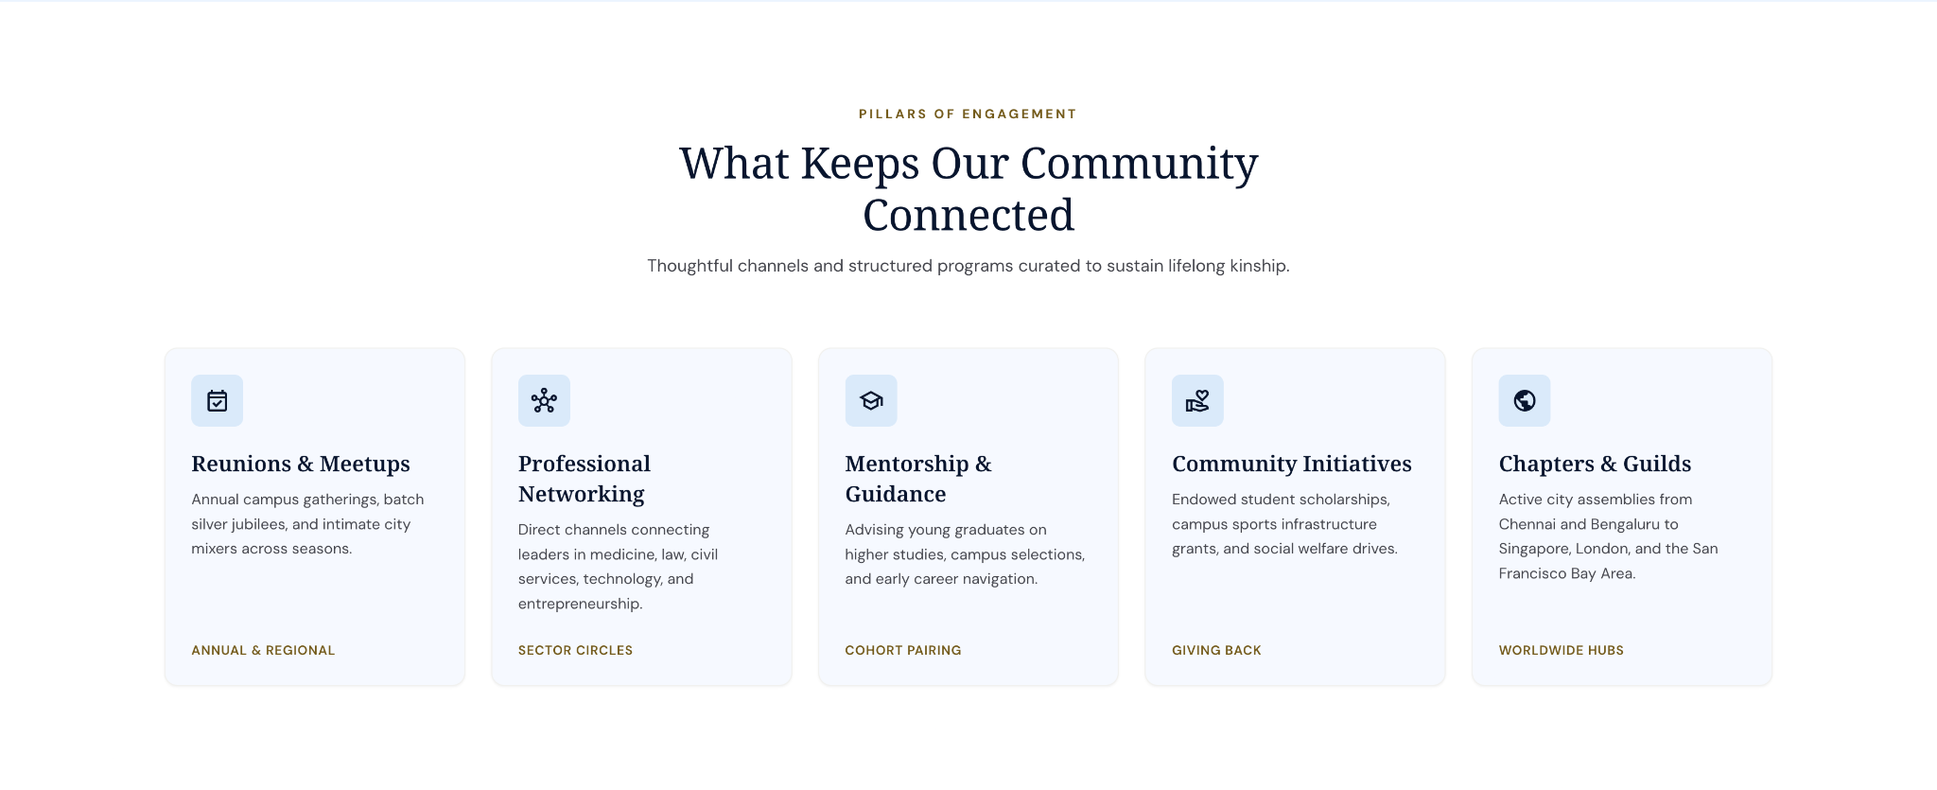

SECTION 4: MAHATMA APP
Visual Direction - Option A Actual mobile app screens
Visual Direction - Option B Phone mockup surrounded by feature cards
THE MAHATMA ALUMNI APP
Your Mahatma Community. In Your Pocket.
Stay connected wherever you are. Discover alumni, explore chapters, register for events, contribute to initiatives, and stay updated with community activities.
Feature Cards
👥 Alumni Directory
📅 Events & Reunions
🌏 Chapters & Communities
🤝 Mentorship & Networking
❤️ Volunteer & Contribute
🔔 Updates & Announcements
CTA
Explore The App
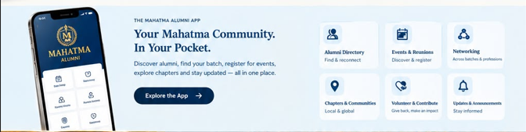
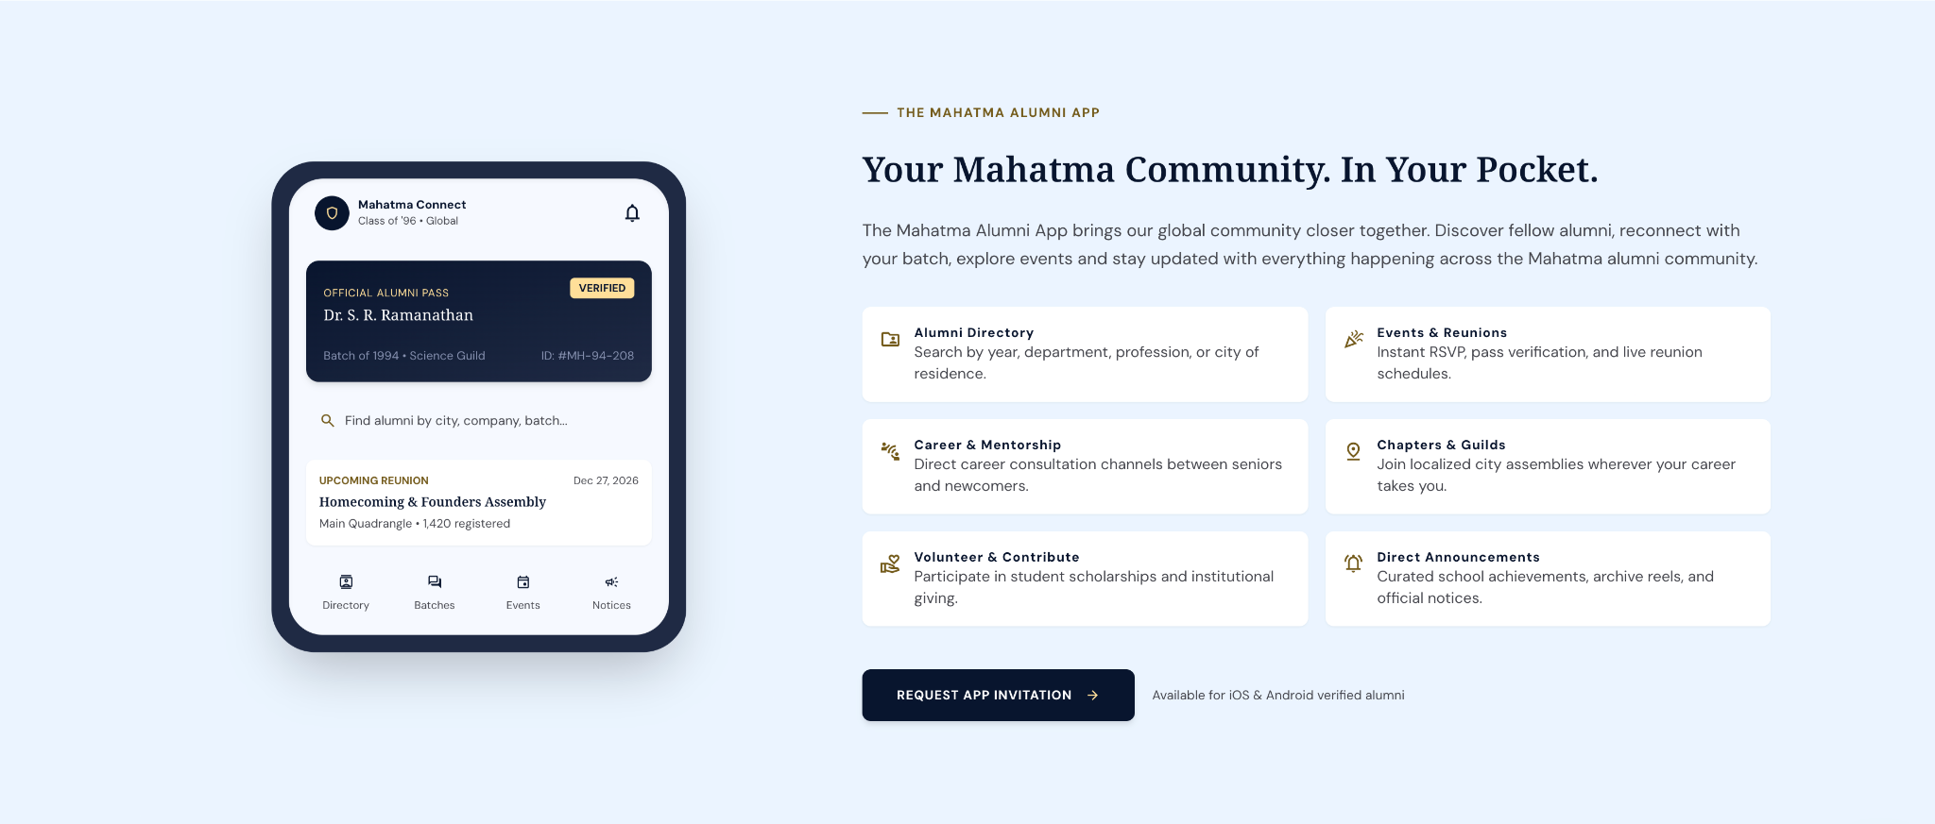
SECTION 5: HOMECOMING 2026
Visual Direction - Option A Premium evening event with lights
Visual Direction - Option B School campus transformed into reunion venue
Left
MAHATMA ALUMNI HOMECOMING 2026
Center
Memories. People. Journeys. One Mahatma Family.
CONNECT • CONTRIBUTE • CELEBRATE
Right
📅 DEC 27, 2026
📍 IDA Scudder Auditorium, Madurai [Mahatma Sponsorship | PDF] (Insert brochure/event agenda link)
CTA
Register Your Interest

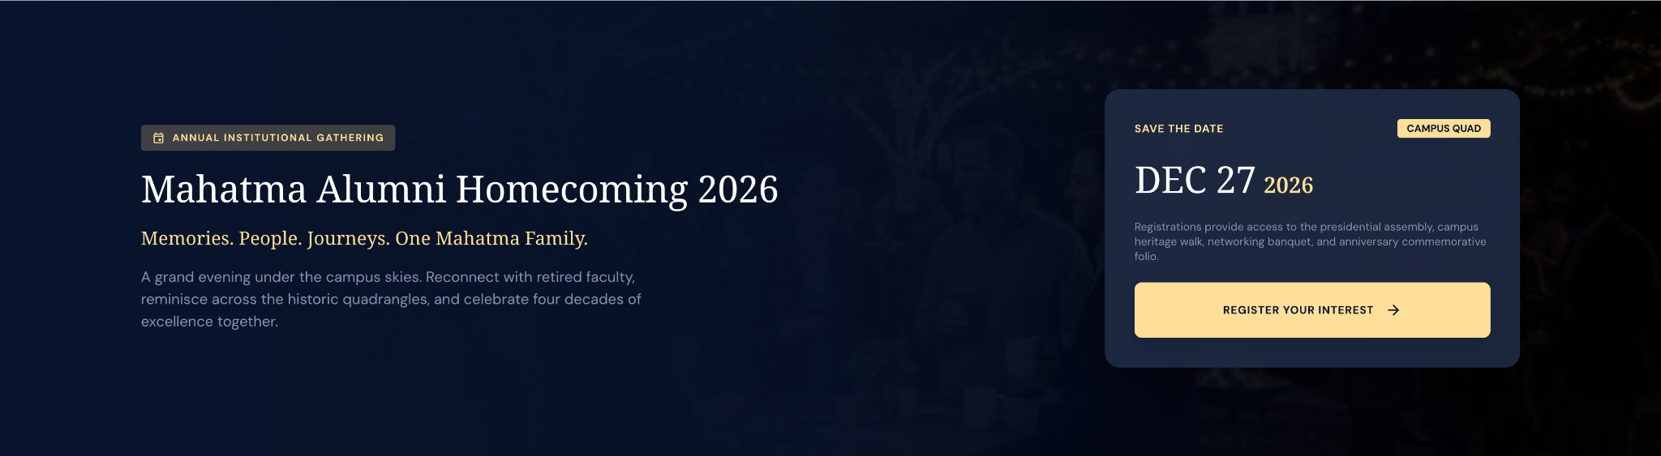

SECTION 6: COUNCIL & LEADERSHIP
This is the one section I would add that is not prominent in the sample.
Visual Direction - Option A Premium hierarchy infographic
Visual Direction - Option B Connected circles with icons and lines inspired by governance structure
HW WE ARE ORGANIZED
Built By Alumni. For Alumni.
The Association is powered by alumni leaders, chapter teams, batch representatives, and volunteers working together to strengthen lifelong connections across the Mahatma community.
Structure
Core Council Strategic direction, governance, and stewardship.
↓
Executive Council Programs, engagement, chapters, and community initiatives.
↓
Chapters Local alumni communities across regions and countries.
↓
Batch Representatives Represent and connect all batches.
↓
Volunteers & Members The heart of the Mahatma Alumni community.
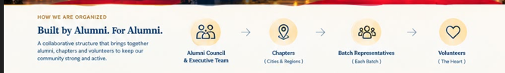
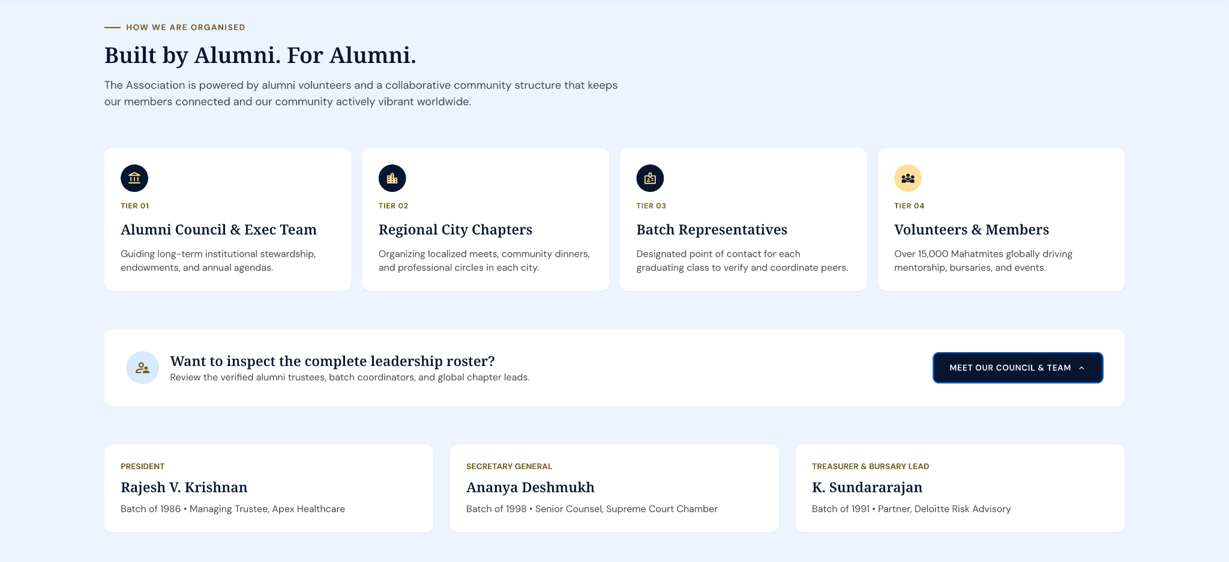
(once body is formed, we can provide a info on association leadership) Keep placeholders as of now similar to below)
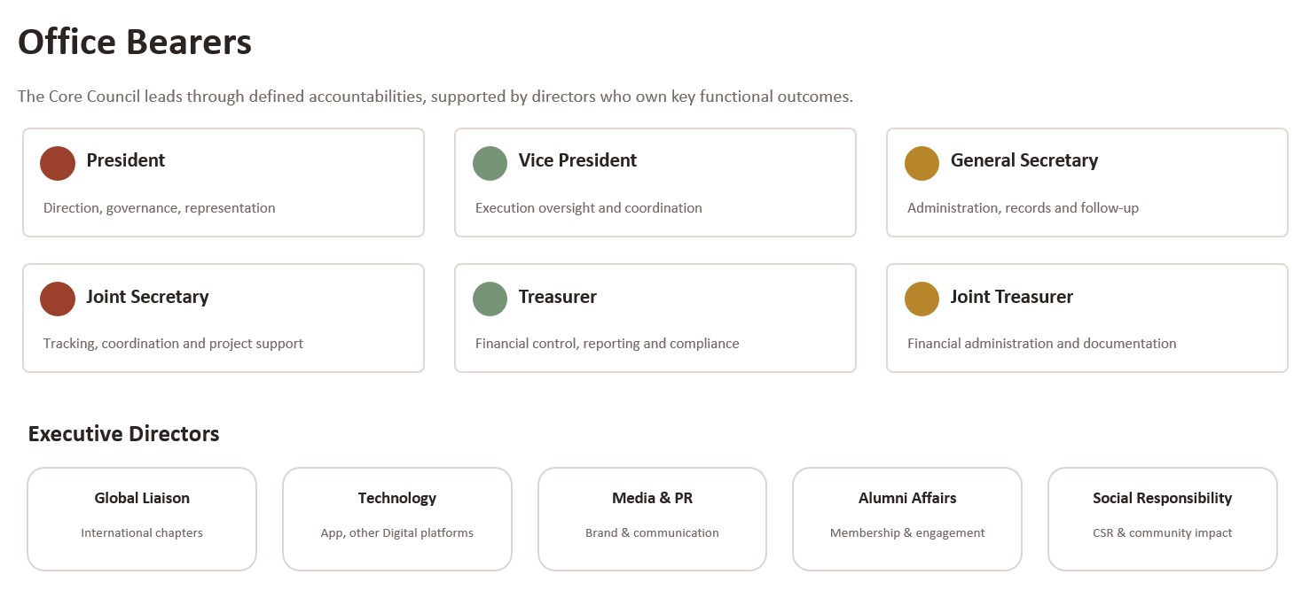
SECTION 7: GLOBAL COMMUNITY (TBC)
Visual Direction - Option A | World map with glowing chapter locations
Visual Direction - Option B | World map with chapter pins and alumni photos
OUR GLOBAL COMMUNITY
One Mahatma Family. Across The World.
More than 10,000 alumni across 20+ countries remain connected through active chapters, events, initiatives, and lifelong friendships.
Chapter List
USA, Canada, UK & Europe, Gulf, Singapore, Other Asia, Australia & New Zealand
Chennai, Bengaluru, Madurai
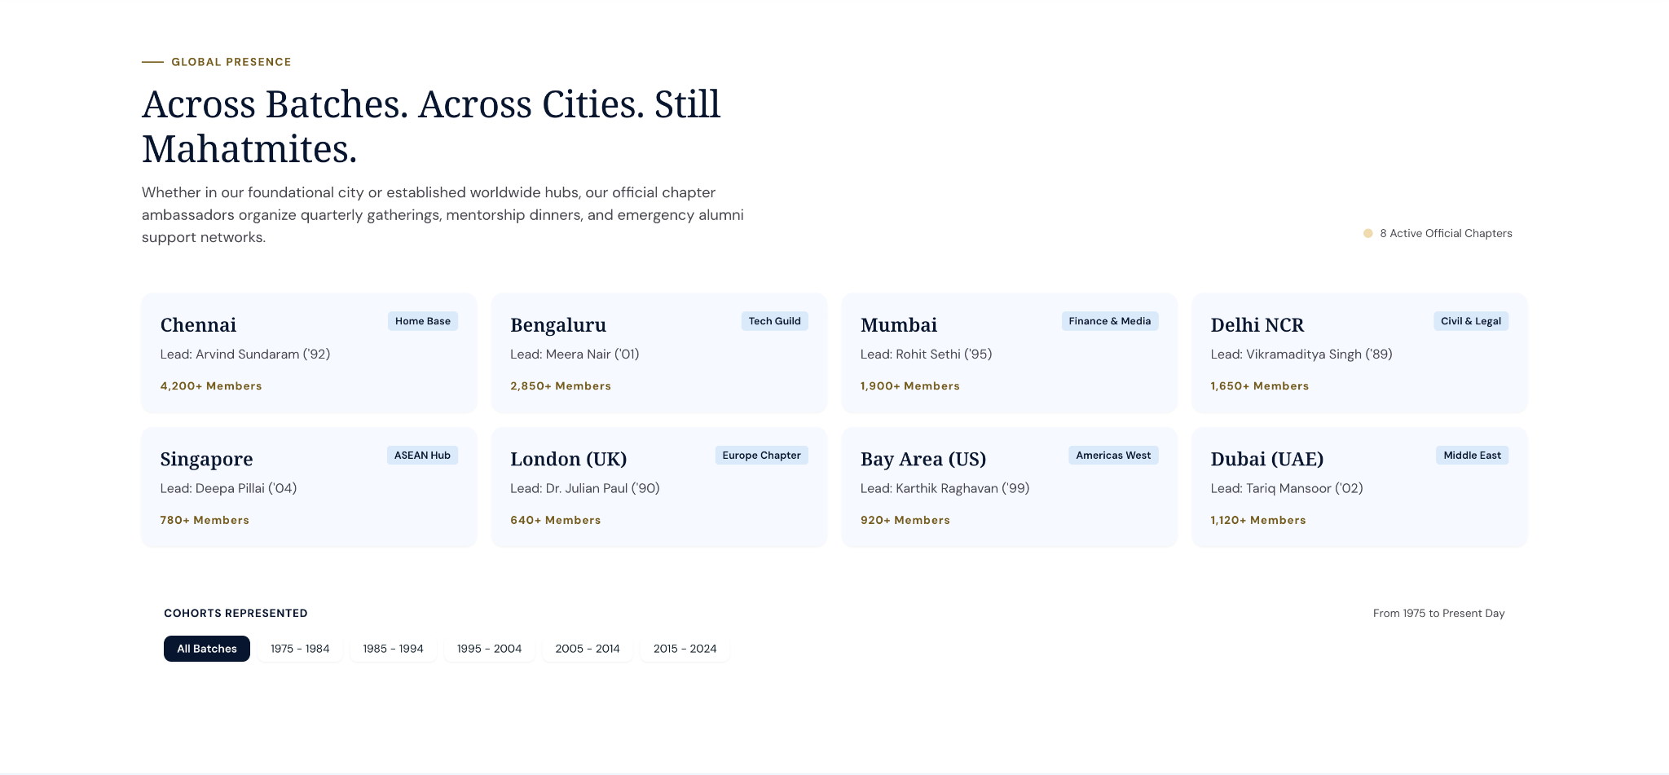
SECTION 8: Memories & Highlights (or) OUR COMMUNITY AT A GLANCE
A Legacy That Continues To Grow
Across cities, countries, professions, and generations, Mahatmites continue to stay connected through shared experiences, lifelong relationships, and a common foundation built at Mahatma.
10,000+
Alumni Worldwide
20+
Countries
10
Active Chapters
Visual
Instead of event cards, use a single wide photography strip. Use 3 images across the width:
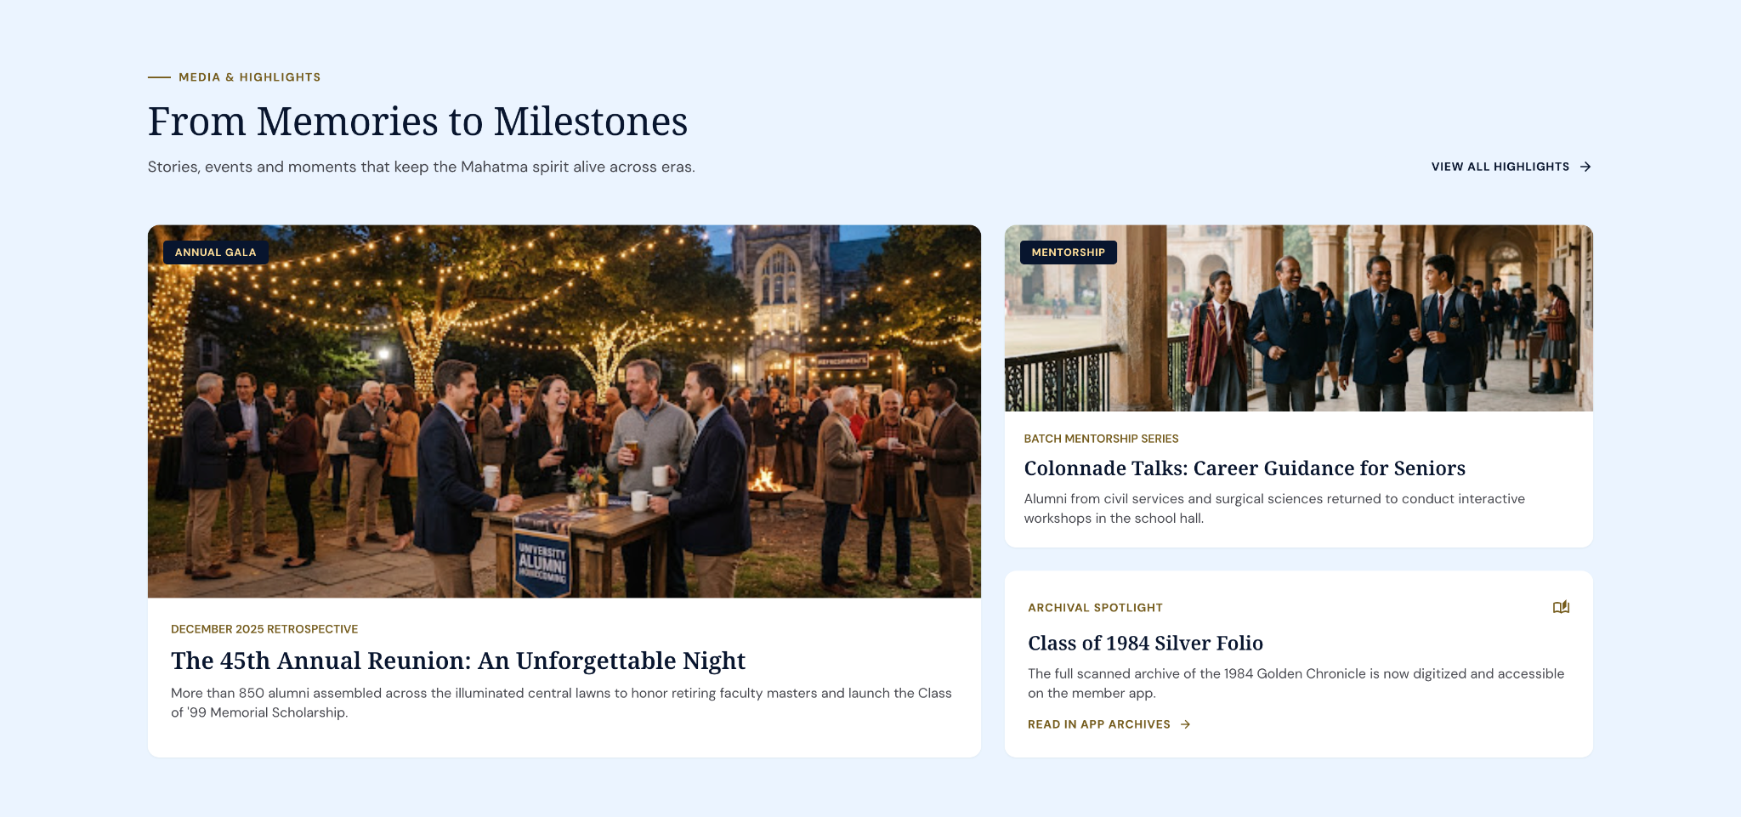

SECTION 9: GET INVOLVED
Visual Direction - Option A Community volunteering
Visual Direction - Option B Alumni mentoring younger students
Card 1
Partner With The Mahatma Community
Support initiatives, programs, events, and opportunities that strengthen alumni engagement and create lasting impact.
CTA
Become A Partner

Card 2
There's A Place For Every Mahatmite
Reconnect, mentor, volunteer, contribute, and help shape the future of the community.
CTA
Get Involved
Accent Script
Stronger Together

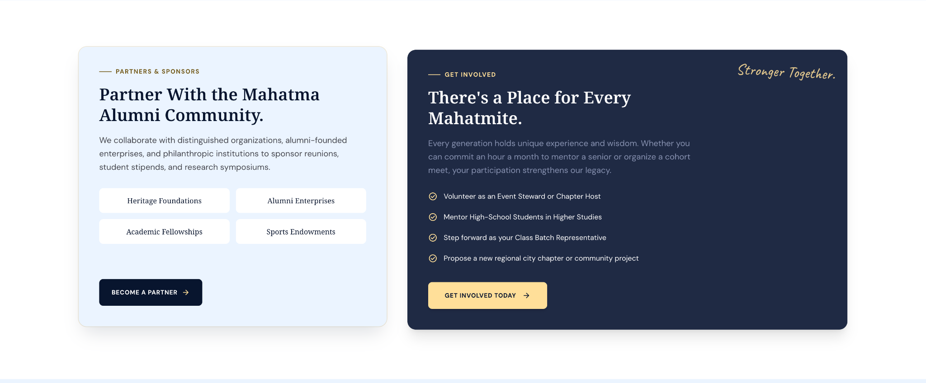

SECTION 10: FINAL CTA/Contact
Visual Direction - Option A School building faded into alumni gathering
Visual Direction - Option BPremium navy-gold background with logo watermark
Once A Mahatmite. Always A Mahatmite.
Body Copy
Reconnect with old friends, discover new opportunities, and remain part of the community that continues long after graduation.
CTA
Join Our Community
Download The App
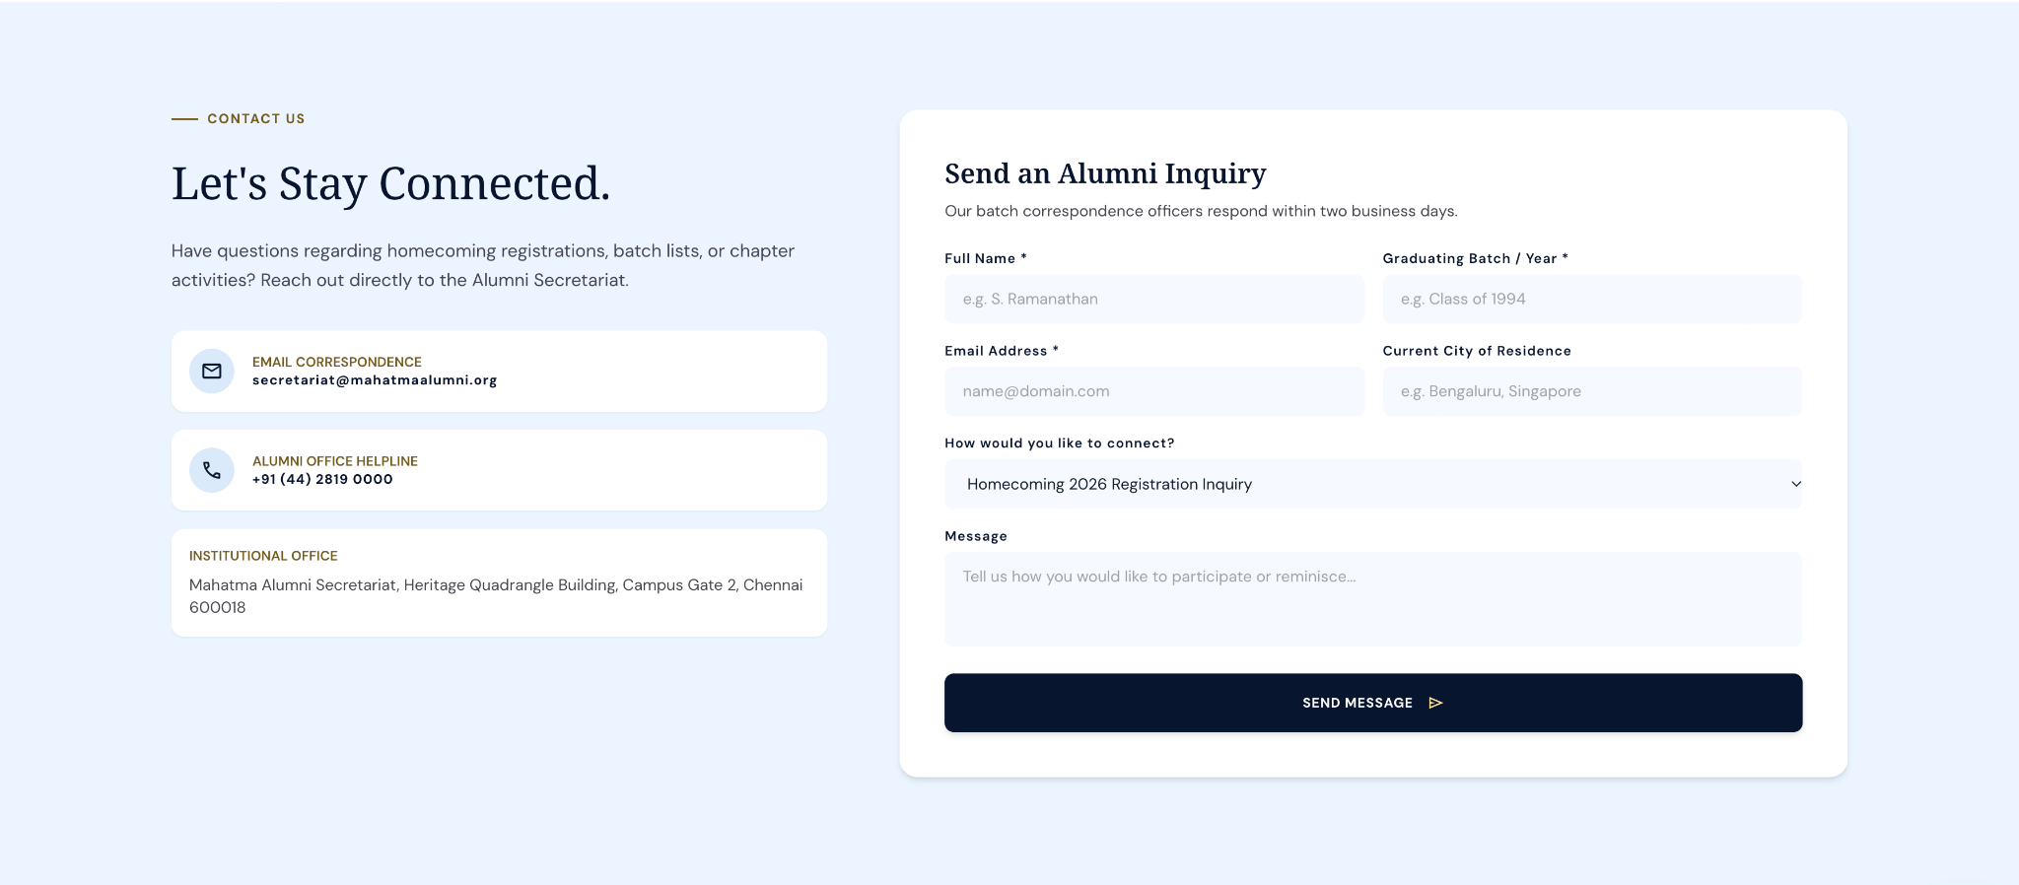

Final Section: FOOTER
Tagline
One School. Many Generations. Forever Connected.
CONNECT • CONTRIBUTE • CELEBRATE
Quick Links
About Us
Alumni App
Homecoming 2026
Get Involved
Partners
Contact
Social Icons
Instagram
LinkedIn
YouTube
Facebook
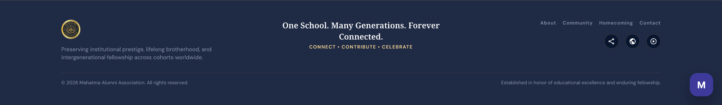

Final Reference
